Basic Questionnaire

1. Have you played Minesweeper before?
2. When looking for a minesweeper game what do you look for?
3. What aspects of minesweeper do you like and dislike?
4. Are there any features you wish were included in minesweeper?
5. Any other relevant information you want to add

Extended Questionnaire

1. In Minesweeper, an element of luck is present from the first click. Do you think it should be fully skill based or still include an element of luck?
2. No luck, fully skill based
3. Reduced amounts of luck, but majority skill based
4. Keep it the same
5. Lots of game modes and features with less resemblance to original game
6. A few custom features with close resemblance to the original game
7. Do you think minesweeper is easy to understand or too confusing? Why?
8. Do you prefer to have a competitive scoring element in minesweeper, or do you think it should be fully individual? why?
9. What kind of graphics suite minesweeper the best?

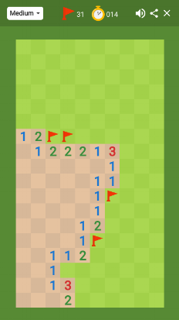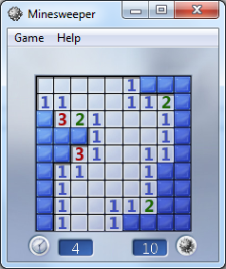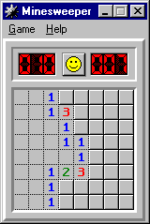

Windows Style

Classical Style

Googles Style